|  |  |
| --- | --- |
| Team ID : | PNT2022TMID51918 |
| Project Name : | Personal Expense Tracker Application |

Create UI to Interact With Application:

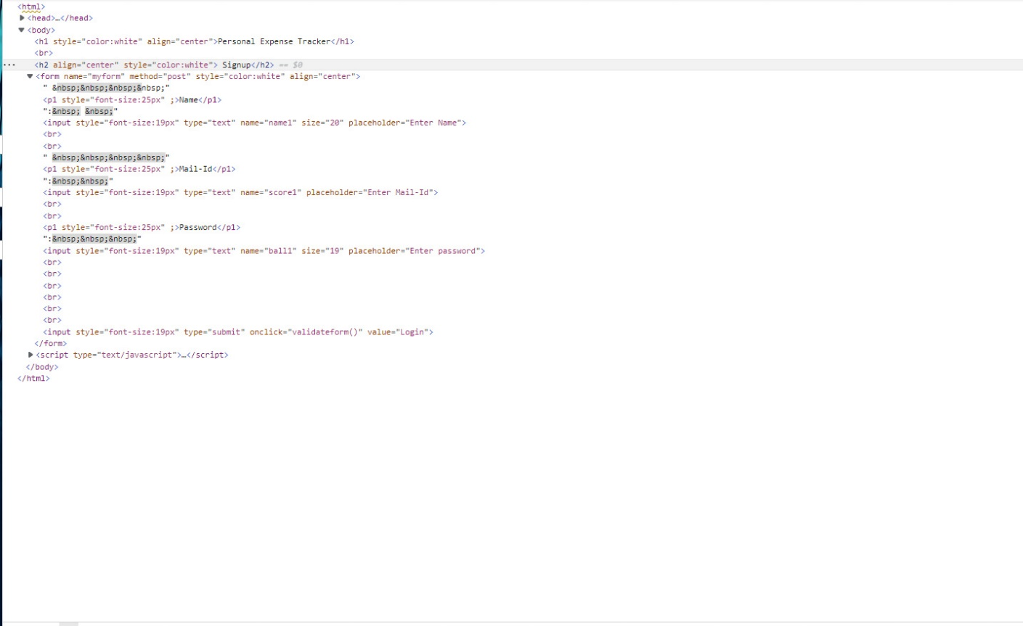

Output:

